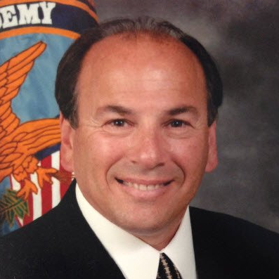

BIOGRAPHY
Name: Rich Cinfio
Title: Advisory Board Member
Company: Premier Risk Solutions LLC

Experience:
Rich is an organizational leader with over 36 years of law enforcement, security and emergency management/business continuity experience who co-authored the “Menu Approach” to threat assessment, whereby a victim chooses response strategies specifically tailored for them resulting in empowerment and enhanced safety. Author of numerous training articles related to human threat assessment and healthcare security, Rich also developed the “The First 15 Minutes”© approach to healthcare emergency management, allowing anyone regardless of experience, knowledge or background to set up an incident command post in a clinical environment within 15 minutes to meet the service needs of an unfolding event. He co-developed the Block, Talk & Walk self-defense program specifically designed to enhance clinician and patient safety.
Rich’s experience includes serving as Incident Commander for visiting dignitaries - a United States President, Vice-President and other heads of state. He co-developed a human behavioral threat assessment program for a large university and instituted a proactive threat assessment protocol in a healthcare environment. Rich is highly trained and experienced in the following skill sets: Human and Facility Threat Assessment, Conflict Resolution, Emergency Preparedness, Policy, Investigations, Leadership/Management, Emergency Management and Security Strategies.
Professional:
During the past five-years, Rich has provided in excess of 200 training presentations regarding threat assessment, active shooter defense, gang awareness, emergency management, conflict resolution and leadership.
Recent experience associated with the complexities of threat assessment involve two high profile case studies - one involving a physician’s conduct which resulted in the introduction of organizational safety strategies, including a restraining order, and the eventual prosecution for violations of the law; the second case involves over 600 threats received by a world renowned artist. Rich can speak from real experiences on how to initiate discussion for the need of a robust threat assessment program and implementation strategies.
Rich is a retired Police Captain and previous Public Safety Director and Emergency Manager for two hospitals in California and John H. Stroger Hospital in Chicago (Cook County), Illinois. He is a graduate of the FBI National Academy, West Point Leadership Program, Command College, Gavin De Becker and WAVER-21 threat assessment programs and San Jose State University.

